**FATMANUR YAMAN – 2019402204**

**ASSIGNMENT**

**IE202 FALL 2021**

**31.12.2021**

**XYZ GLASS BOTTLE MANUFACTURER**

The XYZ glass bottle manufacturer problem is a transportation problem. The are two choices for transportation that are using the train and the ship. The cost of them are different. Using ships requires additional investment cost. There are 4 different plants (P1, P2, P3, P4) with different limited capacities and there are 5 customers (D1, D2, D3, D4, D5) in different cities.

**1a.** The company does not to invest in ships. Thus, the cost table for the rail must be used. The decision variables are;

* a(i) supplies for supply node i,
* b(j) demands for demand node j,
* r(i,j) the unit cost by rail.

The Objective Value Z = 6520000metin içeren bir resim

Açıklama otomatik olarak oluşturuldu $

P1 to D2 = 200.000

P1 to D4 = 50.000

P1 to Dummy = 40.000

P2 to D1 = 180.000

P2 to D3 = 40.000

P3 to D3 = 120.000

P3 to D5 = 60.000

P4 to D4 = 90.000

P4 to D5 = 190.000

**1b.** The company wants to use ships only. Thus, the cost table for the ships must be used. The decision variables are;

* a(i) supplies for supply node i,
* b(j) demands for demand node j,
* s(i,j) the unit cost by ship,
* c(i,j) the investment cost for ships.

The Objective Value Z = 6205000 $

metin içeren bir resim

Açıklama otomatik olarak oluşturuldu

P1 to D3 = 140.00

P1 to D4 = 140.000

P1 to Dummy = 10.000

P2 to D1 = 180.000

P2 to D2 = 40.000

P3 to D2 = 160.000

P3 to D3 = 20.000

P4 to D5 = 250.000

P4 to Dummy = 30.000

**1c.** If the shipping choice on each route are independent, the choice with the lowest cost is being preferred. The table c(i,j) was created by selecting the minimum of the cost of the rail and the cost of the ship. The decision variables are;

* a(i) supplies for supply node i,
* b(j) demands for demand node j,
* c(i,j) the total cost

metin içeren bir resim

Açıklama otomatik olarak oluşturulduThe Objective Value Z = 6125000 $

P1 to D2 = 140.000

P1 to D4 = 140.000

P1 to Dummy = 10.000

P2 to D1 = 180.000

P2 to D3 = 40.000

P3 to D2 = 20.000

P3 to D3 = 160.000

P4 to D5 = 250.000

P4 to Dummy = 30.000

**metin, bilgisayar, dizüstü, ekran görüntüsü içeren bir resim

Açıklama otomatik olarak oluşturuldu2a.** The situation with the lowest cost is 1c. To estimate the new total cost without solving an LP, the reduced cost (shadow prices) that the dual solution provides has to be used. The marginal value of the second plant (P2) is -0.5. It means that the unit increase in the right hand side of the equation will decrease the Z value 0.5. Thus, when the avaliable supply is increase to 230 from 220, the Z value will decrease 0.5*10*1000 = 5000. The expected value for the Z is 6125000-5000= 6520000 $.

The total cost before the change:

metin, bilgisayar, ekran görüntüsü, dizüstü içeren bir resim

Açıklama otomatik olarak oluşturuldu

The total cost after the change:metin, bilgisayar, ekran görüntüsü, dizüstü içeren bir resim

Açıklama otomatik olarak oluşturuldu

As it is expected, the total cost decreased by 5000.

**2b.** The shadow prices (reduced costs provided by the dual solution) are being used to estimate new total cost without solving an LP again. The estimation of the second customer’s demand has changed to 195 from 200. There is 5 unit difference. The marginal value of the second customer (D2) is 7,0. Thus, the increase in the demand of D2 causes 7,0*5*1000 = 35000 decrase in the objective value. The total cost is 6090000 by decreasing 35000.

metin, bilgisayar, dizüstü, ekran görüntüsü içeren bir resim

Açıklama otomatik olarak oluşturuldu

The total cost before the change:metin, bilgisayar, ekran görüntüsü, dizüstü içeren bir resim

Açıklama otomatik olarak oluşturuldu

metin, bilgisayar, ekran görüntüsü, dizüstü içeren bir resim

Açıklama otomatik olarak oluşturulduThe total cost after the change:

As it is expected, the total cost decreased by 35000.

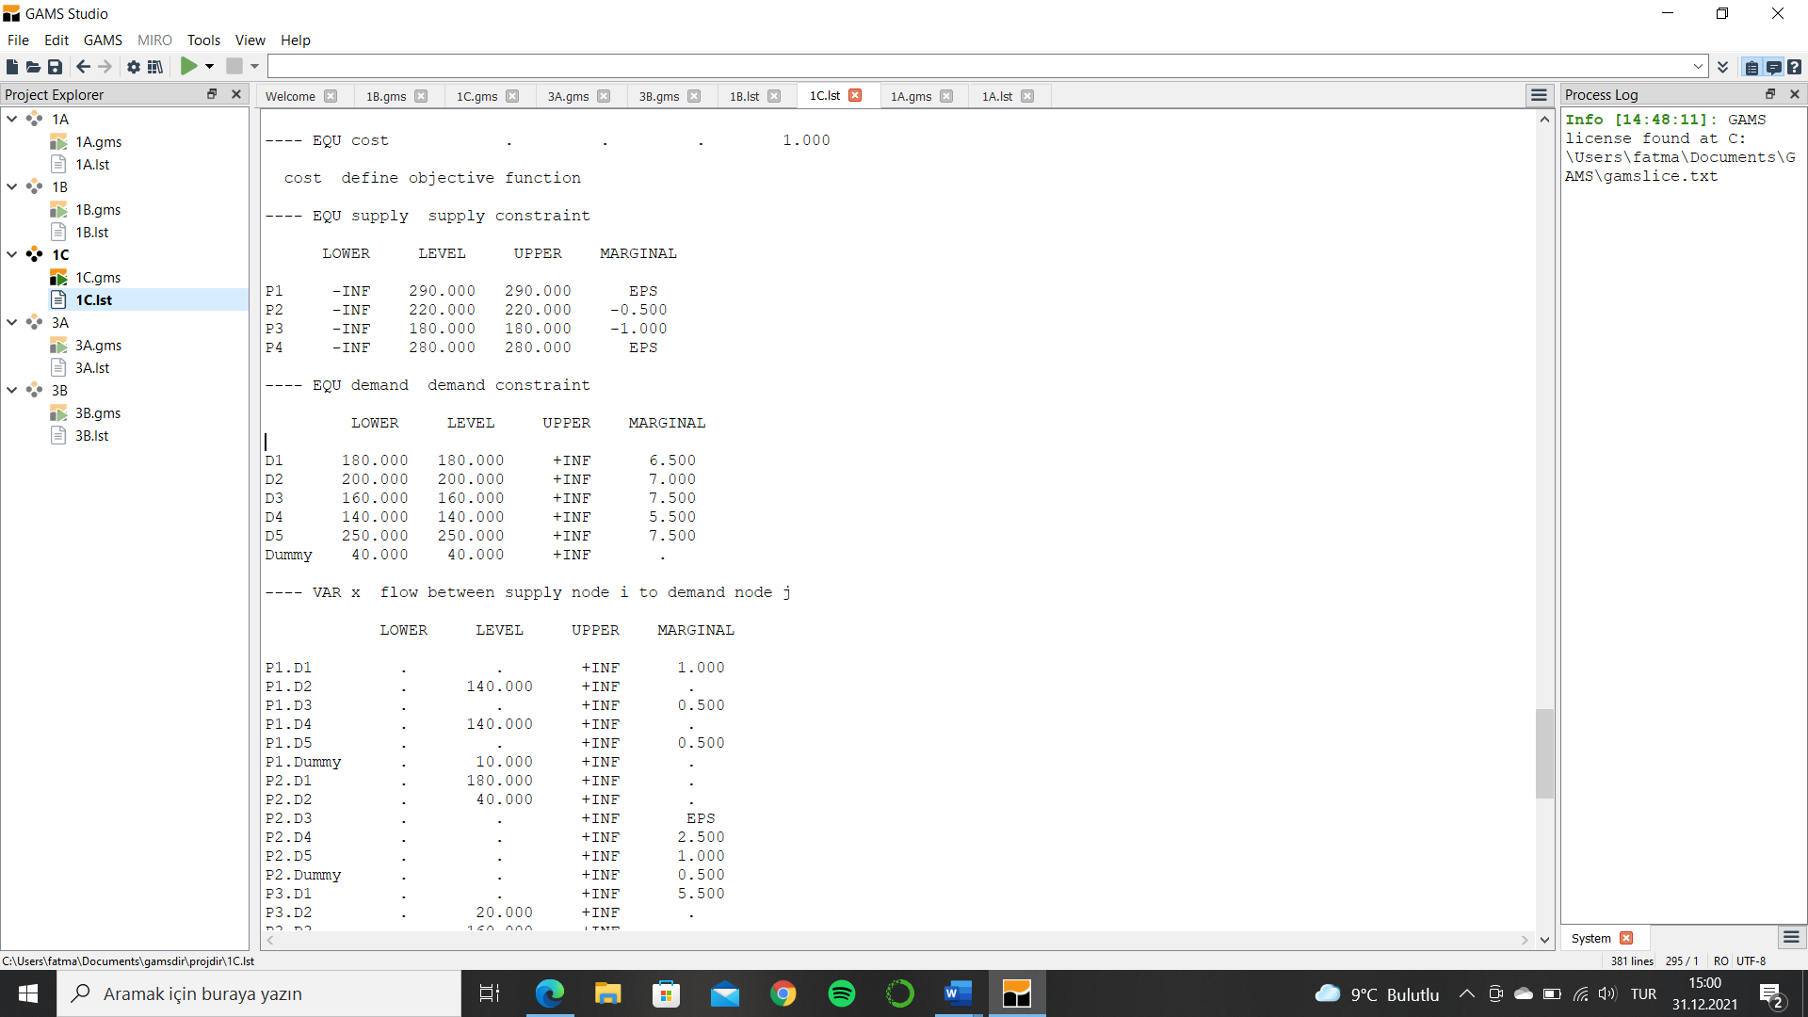**2c.** The reduced cost of the second plant (P2) is -0.5. Normally, 180 change (400-220) in the capacity would cause to 180*0.5*1000=90000 $ decrease in the cost value. The expected Z value is 6125000-90000 = 6035000 $.

metin içeren bir resim

Açıklama otomatik olarak oluşturulduWhen the problem is resolved, it is obvious that the distribution of the transported goods ande the basis have changed. Thus, calculating the new objective value based on the previous basis is giving the wrong answer.

metin içeren bir resim

Açıklama otomatik olarak oluşturuldu

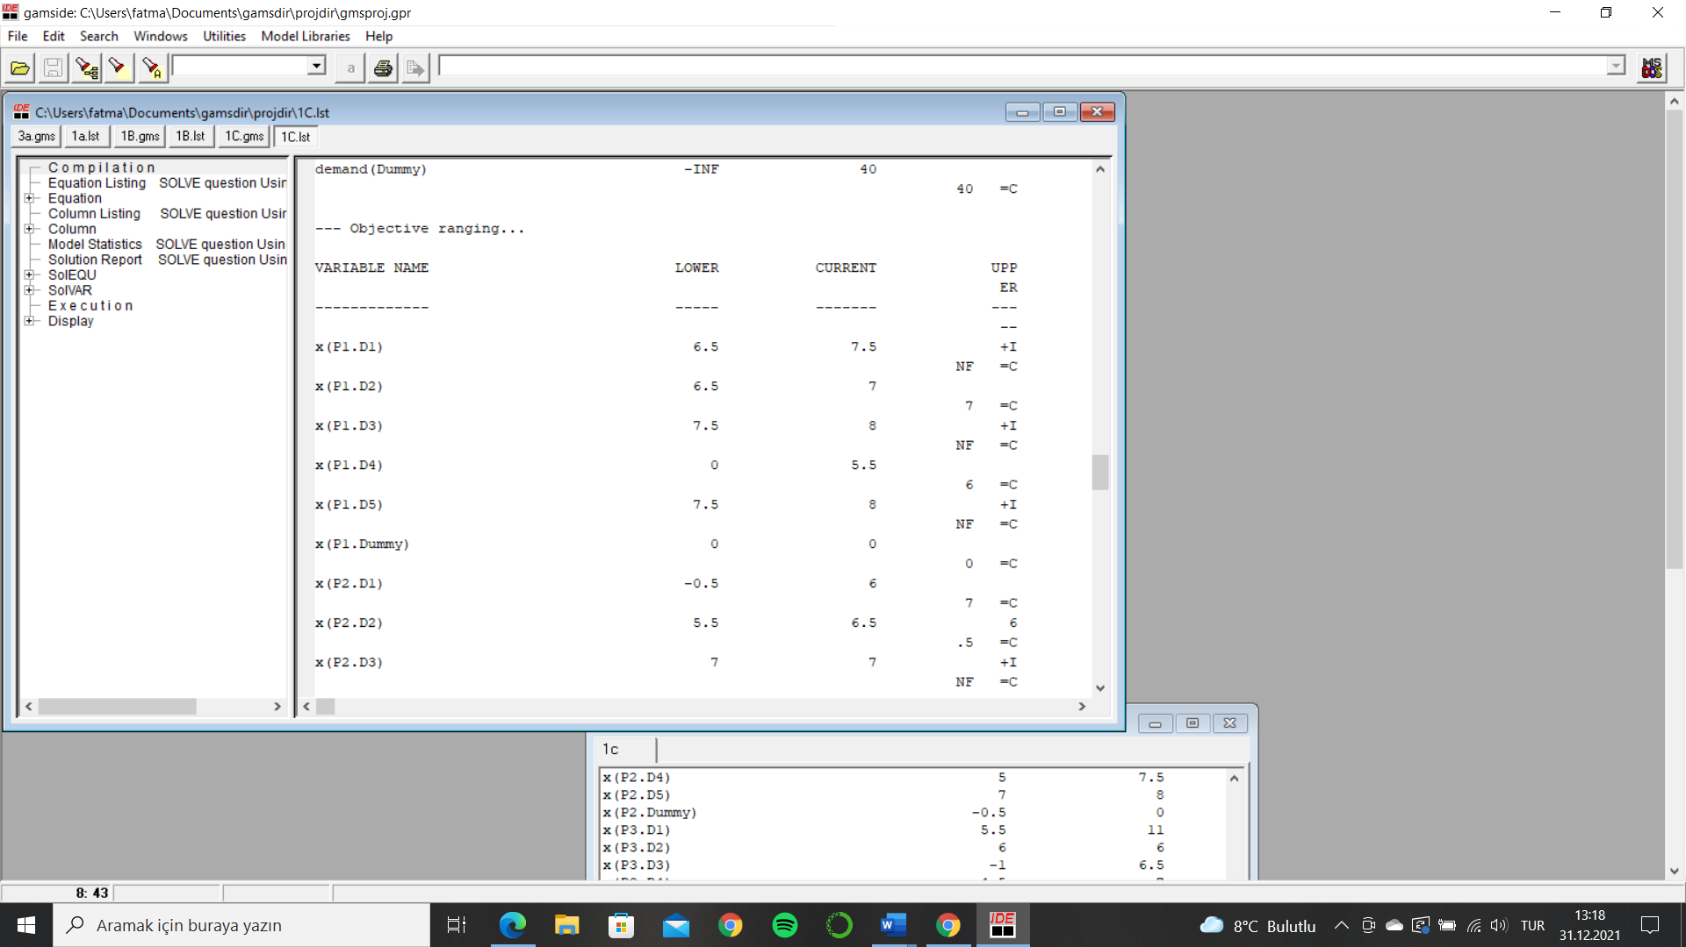**2d.** The first column is VARIABLE NAME, second column is LOWER value, third column is CURRENT value, and the last column is UPPER value for the variable x that shows the transported amount to Customer 4 from Plant 1. The range is [0,6]*10000 = [0,6000$]. In that range, the optimal value is not changing.

**2e.** The difference between the lower value and current value determines the minimum decrease in the shipping cost on 3-1 route because in the range [5.5,11], the plan will not change. It is the minimum decrease in the shipping cost that will create a change in the plan.

(11-5.5)*1000=5500$

metin, ekran görüntüsü, bilgisayar içeren bir resim

Açıklama otomatik olarak oluşturuldu

**3a.** There are two options for the transportation. Either the transportation will be made with using trains and ships, hence the investment cost occurs, or it will be made by rented ships. The rent is 350000$ per ship and it is independent of the flow on that route. Thus, the effect of the objective function of it is independent from x values. The decision variables are in the MIP formulation;

* x(i,j) flow between supply node i to demand node j by using ship or train
* t(i,j) flow between supply node i to demand node j by using rented ships
* y(i,j) determines the decision, rent or buy
* z the total cost

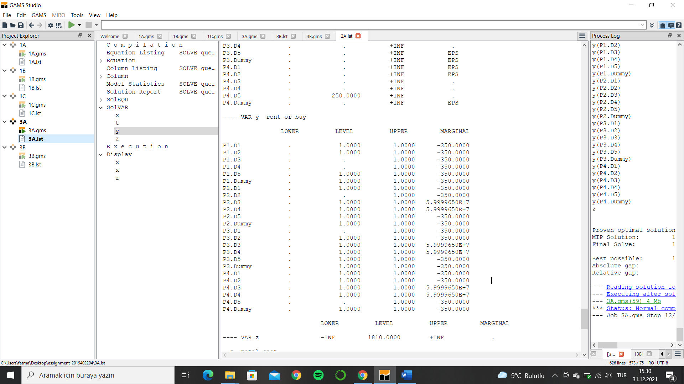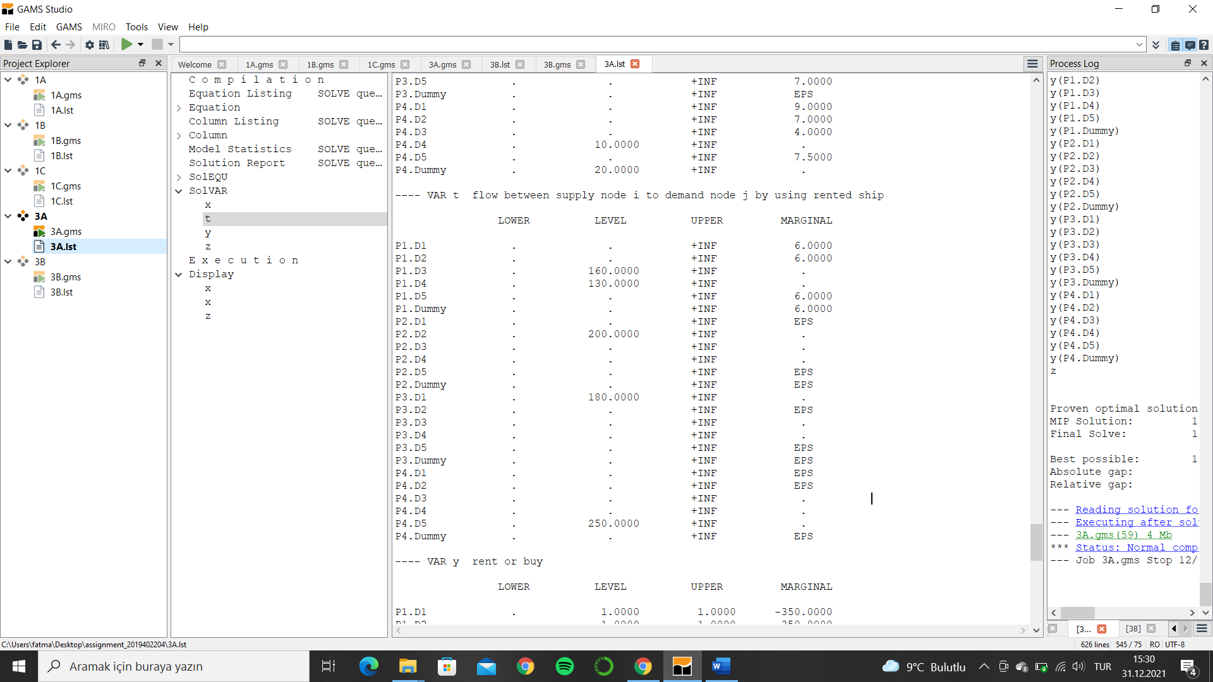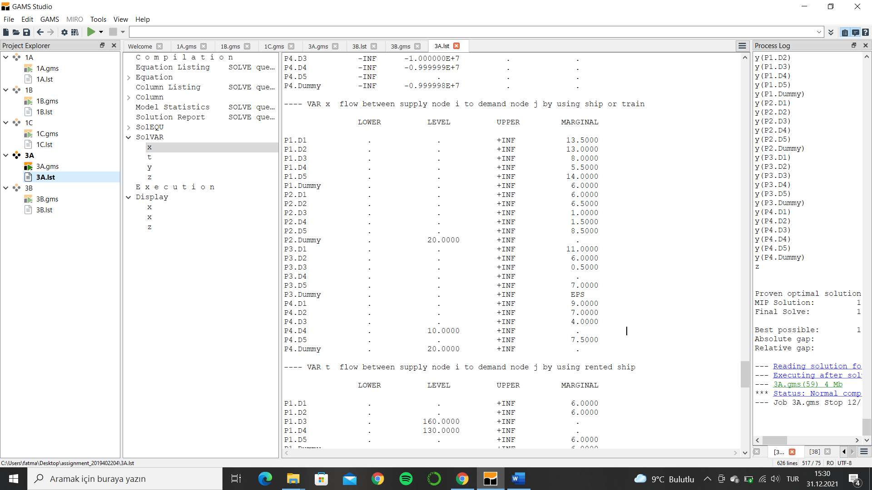The Objective Value Z = 1810000 $

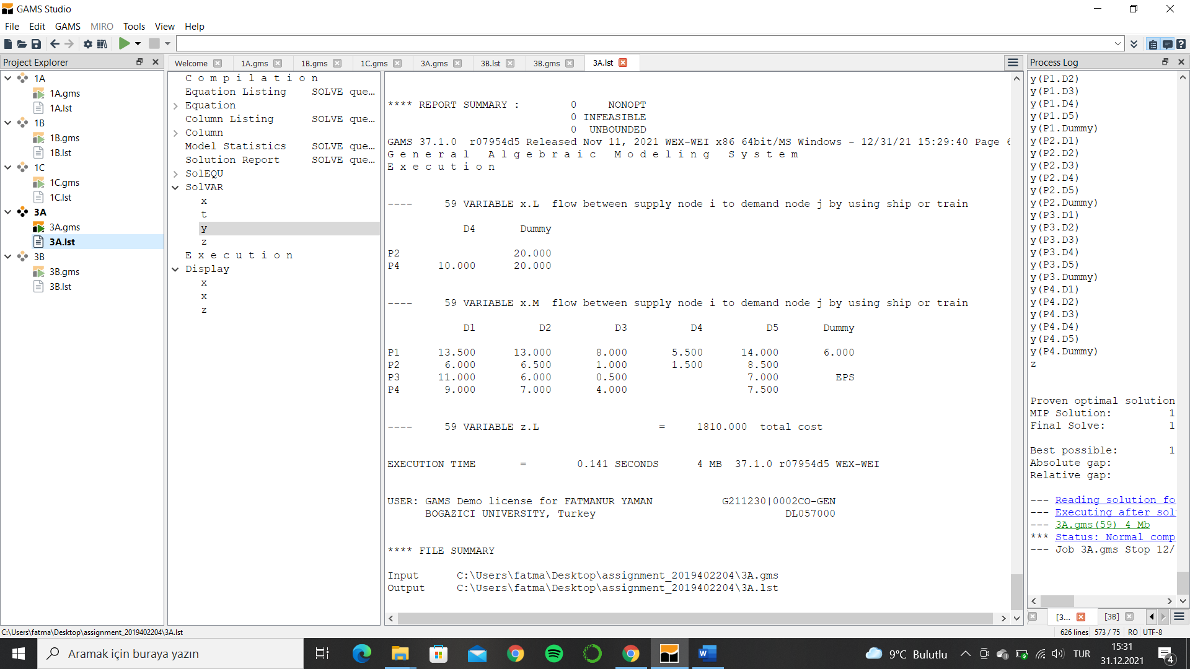

**3b.** The new constraints should add to the equations. The constraint that limits the number of rented ships and the restriction between P1.D3 and P3.D3 should add to the equations. The decision variables are:

* x(i,j) flow between supply node i to demand node j by using ship or train
* t(i,j) flow between supply node i to demand node j by using rented ships
* y(i,j) determines the decision, rent or buy
* z the total cost

The Objective Value Z = 7000000 $

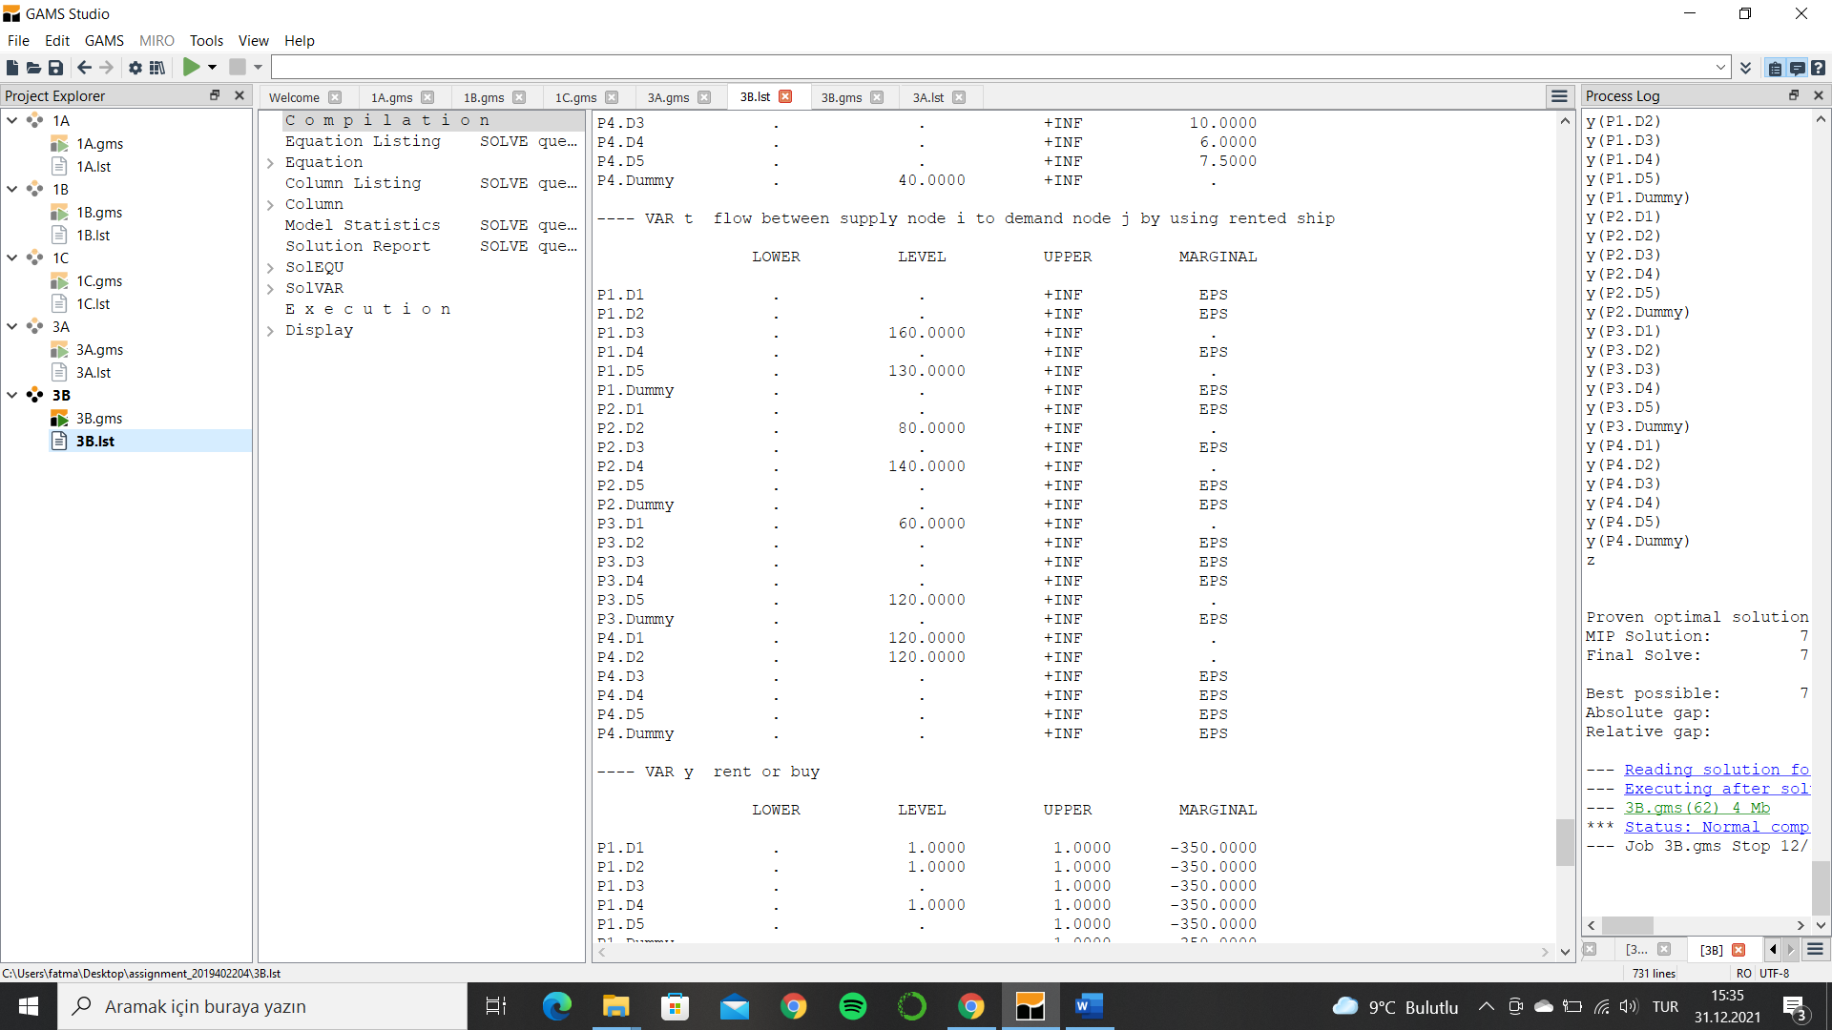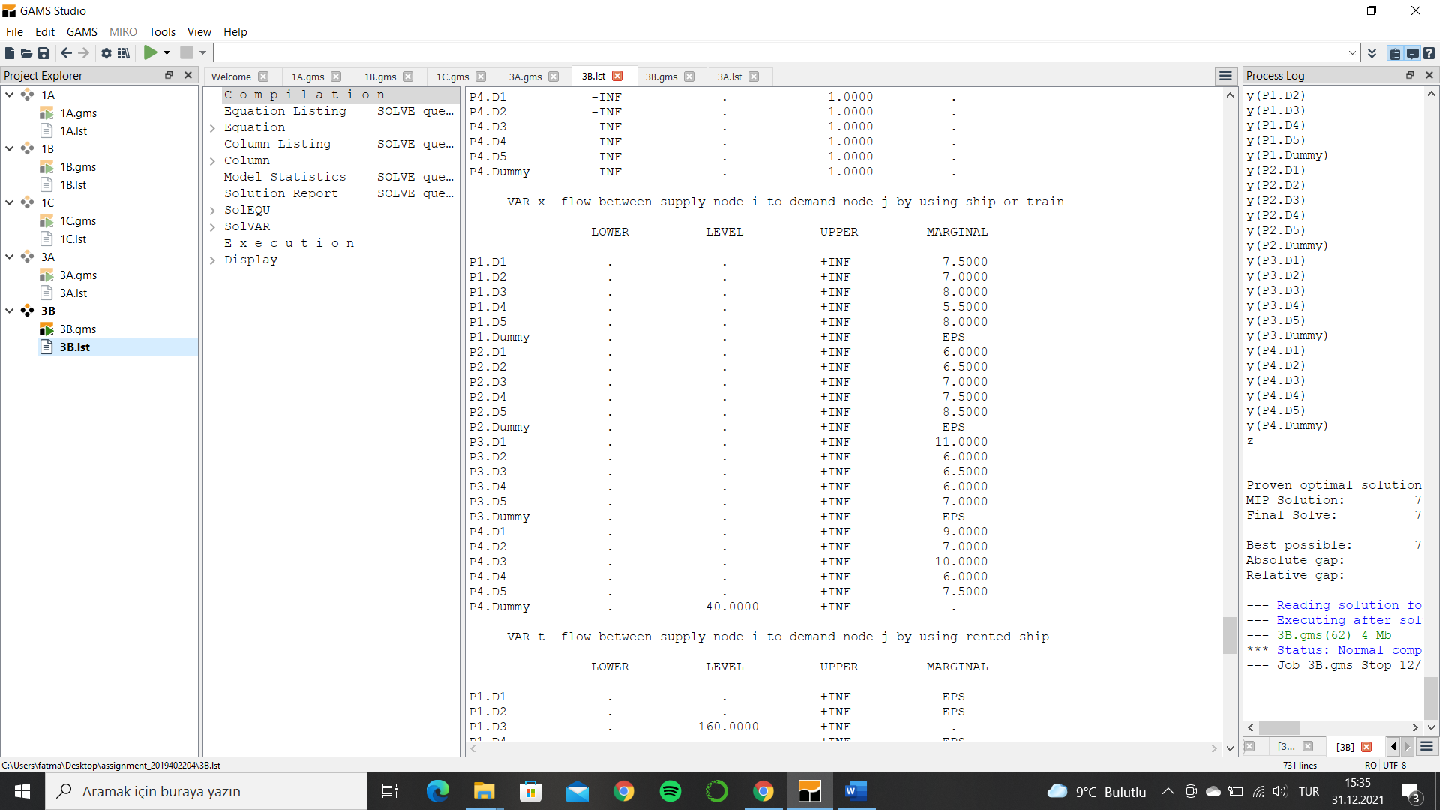

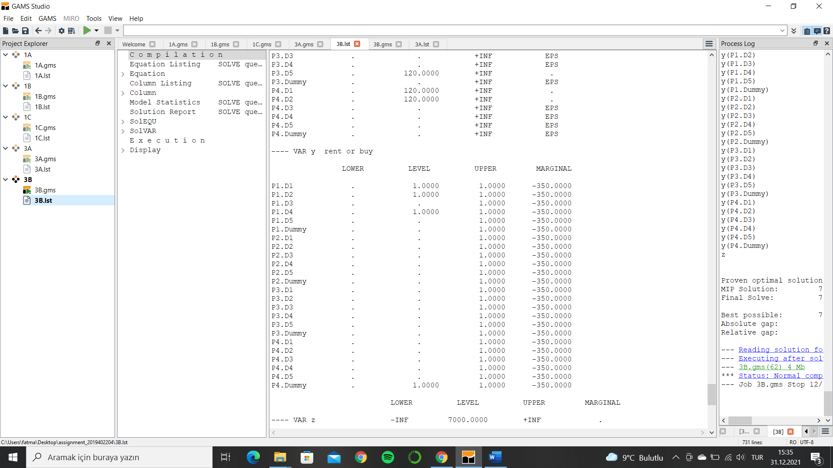

metin içeren bir resim

Açıklama otomatik olarak oluşturuldu